CHAPTER 14
NONPARAMETRIC METHODS

SECTION EXERCISES
14.1 d/p/e Nonparametric tests make no assumptions about the specific shape of the population from which a sample was drawn; most of the tests in previous chapters assumed a normally distributed population.

14.2 d/p/m The advantages of nonparametric tests include (1) having to make fewer assumptions about the underlying population; (2) being able to use small sample sizes; (3) being able to use nominal and ordinal data; and, (4) using simpler calculations. The disadvantages of nonparametric tests include
(1) less efficiency and a smaller power of the test and (2) greater reliance on statistical tables.

14.3 d/p/m A nonparametric test should be used instead of its parametric counterpart whenever:
(1) data are of the nominal or ordinal scales of measurement, or (2) data are of the interval or ratio scales of measurement but one or more other assumptions, such as the normality of the underlying population distribution, have not been met.

14.4 d/p/m The four scales of measurement can be distinguished by the level of differentiation and ratio. Measurements on the nominal scale use numbers only to identify membership in a group or category.
The ordinal scale uses numbers to rank items in terms of having more or less of a characteristic; distances are meaningless. The interval scale includes ranks, but it also permits us to describe how much more or less of a characteristic one object possesses compared to another. Finally, the ratio scale indicates both how much more or less of a characteristic is present, and ratios and a zero point are also meaningful.

14.5 d/p/m The parametric counterpart to the Wilcoxon signed rank test is the one-sample t-test.
The one sample t-test assumes that the underlying population is normally distributed and that the data are continuous on the ratio or interval scale. The Wilcoxon signed rank test assumes that the underlying population is approximately symmetric and that the data are continuous on the ratio or interval scale.

14.6 c/a/m The null and alternative hypotheses are H₀: M = 4.9 and H₁: M ≠ 4.9.
This is a two-tail test with 8 observations, and none is equal to the hypothesized median. At the 0.05 level, we will reject H₀ if the calculated test statistic (W = the sum of the R+ ranks) is less than 4 or greater than 32. The Minitab printout is shown below.

Wilcoxon Signed Rank Test: x
Test of median = 4.900 versus median not = 4.900
N for Wilcoxon Estimated
N Test Statistic P Median
x 8 8 5.5 0.093 3.975

The calculated value of the test statistic is 5.5. Since this is between our critical values, we do not reject H₀. There is no evidence to suggest that the median is not 4.9. Using the table of critical values for the Wilcoxon signed rank test, we find that the p-value for this problem is between 0.05 and 0.10. Using the printout and the p-value approach, we do not reject H₀ because p-value = 0.093 is not < α = 0.05 level of significance for the test.

14.7 c/a/m The null and alternative hypotheses are H₀: M ≤ 37.0 and H₁: M > 37.0.
In this right-tail test, there are 14 observations and none is equal to the hypothesized median. At the 0.01 level, we will reject H₀ if the calculated test statistic (W = the sum of the R+ ranks) is greater than 89. The Minitab printout is shown below.

Wilcoxon Signed Rank Test: x
Test of median = 37.00 versus median > 37.00
N for Wilcoxon Estimated
N Test Statistic P Median
x 14 14 94.5 0.005 41.90

Since W is greater than 89, we reject H₀. There is evidence to suggest that the median is greater than 37.0. Using the table of critical values for the Wilcoxon signed rank test, we find that the p-value for the test is less than 0.005. Using the printout and the p-value approach, we reject H₀ because Minitab’s
p-value = 0.005 is < α = 0.01 level of significance for the test.

14.8 c/a/m The null and alternative hypotheses are H₀: M = 10 hours and H₁: M ≠ 10 hours.
This is a two-tail test with 20 observations, but only 18 that differ from the hypothesized median.
At the 0.05 level, we will reject H₀ if the calculated test statistic (W = the sum of the R+ ranks) is less than 41 or greater than 130. The Minitab printout is shown below.

Wilcoxon Signed Rank Test: hours
Test of median = 10.00 versus median not = 10.00
N for Wilcoxon Estimated
N Test Statistic P Median
hours 20 18 18.5 0.004 8.500

Since W = 18.5 is less than 41, we reject H₀. There is evidence to dispute the director's claim.
Using the p-value approach, we reject H₀ because Minitab's p-value = 0.004 is < α = 0.05 level of significance for the test.

14.9 p/a/m The null and alternative hypotheses are H₀: M ≤ 15 minutes and H₁: M > 15 minutes. This is a right-tail test with 22 observations, but only 21 that differ from the hypothesized median. Because n is large, we can use the normal approximation to the Wilcoxon signed rank test. The calculated test statistic is determined as shown below, and the critical z in this right-tail test is 1.96.
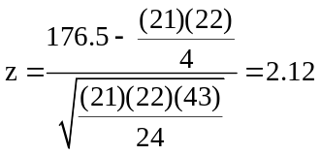 exceeds the critical value of 1.96, and we reject H₀.
With z = 2.12, and using the normal distribution table in the text, we can estimate the p-value as being 1.0000 - 0.9830 = 0.0170. We can also apply the normal approximation using Excel and Data Analysis Plus. The results are comparable to those shown above.
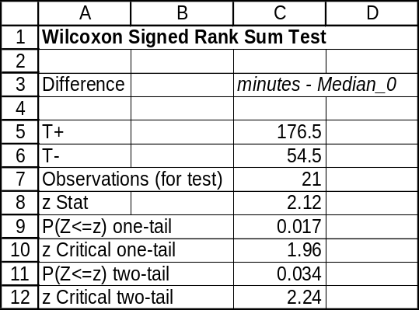
14.10 p/c/m The null and alternative hypotheses are H₀: M = $35 thousand and H₁: M ≠ $35 thousand.
This is a two-tail test and n = 19 observations because one is lost due to a tie with the hypothesized median. At the 0.05 level, we will reject H₀ if the calculated test statistic (W = the sum of the R+ ranks) is less than 47 or greater than 143. The Minitab printout is shown below.

Wilcoxon Signed Rank Test: Salary
Test of median = 35.00 versus median not = 35.00
N for Wilcoxon Estimated
N Test Statistic P Median
Salary 20 19 133.0 0.131 36.90

Since W = 133.0 is between 47 and 143, we do not reject H₀. There is no evidence, at the 0.05 level, to dispute the director's claim. Using the table of critical values for the Wilcoxon signed rank test, we can determine that the p-value for this test is between 0.10 and 0.20. Using the p-value approach, we do not reject H₀ because p-value = 0.131 is not < α = 0.05 level of significance for the test.

The number of observations used in the test is one less than the minimum of 20 recommended for using the normal approximation. However, application of Data Analysis Plus and the normal approximation yields the comparable results shown below.
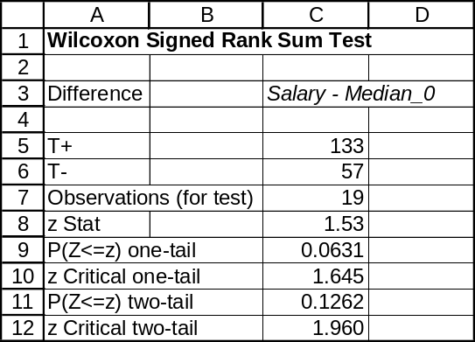

14.11 p/c/m The null and alternative hypotheses are H₀: M = 27.5 years and H₁: M ≠ 27.5 years.
There are 24 observations and none is equal to the hypothesized median. The Minitab printout is shown below. Because p-value = 0.137 is not < α = 0.05 level of significance for the test, we do not reject H₀.
There is no evidence to suggest that the median age at which males in this region are first married differs from that for the nation as a whole.

Wilcoxon Signed Rank Test: Years
Test of median = 27.50 versus median not = 27.50
N for Wilcoxon Estimated
N Test Statistic P Median
Years 24 24 202.5 0.137 30.50

Since we have ≥ 20 nonzero differences, we can also apply Data Analysis Plus and the z-test approximation to the Wilcoxon signed rank test. Using this method, we obtain the comparable results shown below.
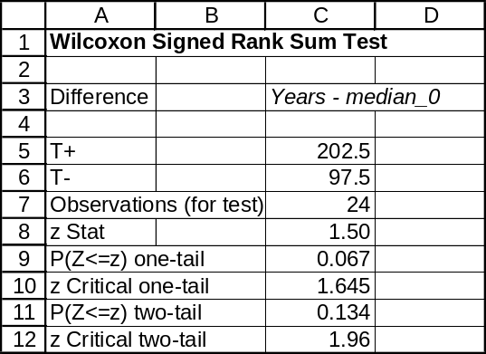

14.12 d/p/m The parametric counterpart to the Wilcoxon signed rank test for paired samples is the paired samples t-test. Both tests assume continuous data on the interval or ratio scale, and the data come in pairs. The t-test assumes that both underlying populations are normally distributed, whereas the Wilcoxon test assumes only that both distributions are fairly symmetric in shape.

14.13 c/a/m With d = x₁ - x₂ for each pair, the null and alternative hypotheses are:
H₀: m_{d} ≤ 0 and H₁: m_{d} > 0. This is a one-tail test with 9 observations, and we will not lose any when we calculate the differences. At the 0.10 level, we will reject H₀ if the calculated test statistic (W = the sum of the R+ ranks) is greater than 34. The Minitab printout is shown below.

Wilcoxon Signed Rank Test: diff
Test of median = 0.000000 versus median > 0.000000
N for Wilcoxon Estimated
N Test Statistic P Median
diff 9 9 34.5 0.087 0.8500

Since W is greater than 34, we reject H₀ at the 0.10 level. There is evidence to suggest that the median difference is greater than 0. Alternatively, using Minitab and the p-value approach, because p-value = 0.087 is < α = 0.10 level of significance for the test, we reject H₀.

14.14 c/a/m With d = x₁ - x₂ for each pair, the null and alternative hypotheses are:
H₀: m_{d} = 0 and H₁: m_{d} ≠ 0. This is a two-tail test with 10 observations, and we will lose one when we take the differences. At the 0.10 level, we will reject H₀ if the calculated test statistic (W = the sum of the R+ ranks) is less than 9 or greater than 36. The Minitab printout is shown below.

Wilcoxon Signed Rank Test: diff
Test of median = 0.000000 versus median not = 0.000000
N for Wilcoxon Estimated
N Test Statistic P Median
diff 10 9 13.5 0.314 -0.2500

Since W = 13.5 falls within the 9 to 36 limits, we do not reject H₀. At the 0.10 level, we conclude that the median difference could be 0. Alternatively, using Minitab and the p-value approach, because p-value = 0.314 is not < α = 0.10 level of significance for the test, we do not reject H₀.

14.15 p/a/m With d = x₁ - x₂ (spam messages before filter minus spam messages after filter) for each pair, the null and alternative hypotheses are H₀: m_{d} ≤ 0 and H₁: m_{d} > 0. This is a one-tail test with 9 observations, and we will not lose any when we calculate the differences. At the 0.05 level, we will reject H₀ if the calculated test statistic (W = the sum of the R+ ranks) is greater than 36. The Minitab printout is shown below.

Wilcoxon Signed Rank Test: Bef-Aft
Test of median = 0.000000 versus median > 0.000000
N for Wilcoxon Estimated
N Test Statistic P Median
Bef-Aft 9 9 39.0 0.029 3.000

Since W = 39.0 is greater than 36, we reject H₀ at the 0.05 level. There is evidence to suggest that the median difference is positive and that the spam filter is effective. Alternatively, using Minitab and the
p-value approach, because p-value = 0.029 is < α = 0.05 level of significance for the test, we reject H₀.

14.16 c/a/m With d = x₁ - x₂ for each pair, the null and alternative hypotheses are H₀: m_{d} = 0 and
H₁: m_{d} ≠ 0. This is a two-tail test with 8 observations, and we will lose one when we take the differences. At the 0.05 level, we will reject H₀ if the calculated test statistic (W = the sum of the R+ ranks) is less than 3 or greater than 25. The Minitab printout is shown below.

Wilcoxon Signed Rank Test: diff
Test of median = 0.000000 versus median not = 0.000000
N for Wilcoxon Estimated
N Test Statistic P Median
diff 8 7 1.0 0.035 -98.75

Since W is less than 3, we reject H₀. There is evidence, at the 0.05 level, to suggest a difference in spending habits. Alternatively, using the p-value approach, because p-value = 0.035 is < α = 0.05 level of significance for the test, we reject H₀.

14.17 p/a/m With d = x₁ - x₂ for each pair, the null and alternative hypotheses are:
H₀: m_{d} ≤ 0 and H₁: m_{d} > 0. (Note: If the procedure increases efficiency, the times should decrease and d should be greater than zero.) This is a right-tail test with 5 observations, and we will not lose any when we take the differences. At the 0.025 level, we will reject H₀ if the calculated test statistic (W = the sum of the R+ ranks) is greater than 15. This will not occur, since the maximum possible R+ sum is actually 15, but we will carry out the analysis anyway and get its conclusion and p-value. The Minitab printout is shown below.

Wilcoxon Signed Rank Test: differ
Test of median = 0.000000 versus median > 0.000000
N for Wilcoxon Estimated
N Test Statistic P Median
differ 5 5 14.0 0.053 5.250

As anticipated, W (14.0) does not exceed 15, and we do not reject H₀. Alternatively, because
p-value = 0.053 is not < α = 0.025 level of significance for the test, we do not reject H₀. At the 0.025 level, we conclude that the proposed method could be no faster than the current method. Using only the table of critical values for the Wilcoxon signed rank test, we would be able to determine that the p-value for this test is between 0.05 and 0.10.

14.18 p/c/m With x₁ = goals in 1995/96 season, x₂ = goals in 1994/95 season, and d = x₁ - x₂ for each team, the null and alternative hypotheses are H₀: m_{d} ≥ 0 and H₁: m_{d} < 0. This is a left-tail test at the 0.05 level. There are 26 observations, and we do not lose any when we take the differences. The Minitab printout is shown below.

Wilcoxon Signed Rank Test: diff
Test of median = 0.000000 versus median < 0.000000
N for Wilcoxon Estimated
N Test Statistic P Median
diff 26 26 94.5 0.020 -5.500

Because p-value = 0.020 < α = 0.05 level of significance for the test, we reject H₀. At this level,
we conclude that the decrease in goals is due to something other than just random variation from one year to the next. Using Data Analysis Plus and the normal approximation, we obtain the comparable results shown below.
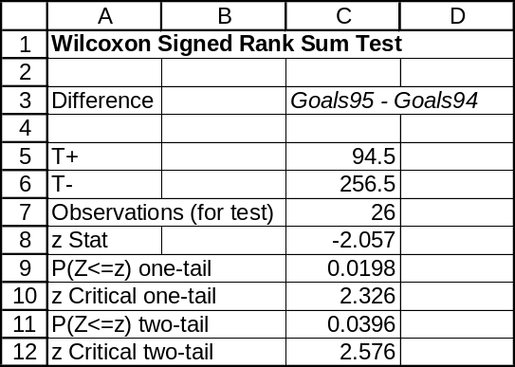

14.19 p/c/m With d = x₁ - x₂ for each pair, the null and alternative hypotheses are:
H₀: m_{d} ≥ 0 and H₁: m_{d} < 0. (Note: If the speed is really increased, d should be less than 0.)
This is a left-tail test with 5 observations, and one observation is lost when we take the differences.
The Minitab printout is shown below.

Wilcoxon Signed Rank Test: diff
Test of median = 0.000000 versus median < 0.000000
N for Wilcoxon Estimated
N Test Statistic P Median
diff 5 4 1.5 0.137 -75.00

The p-value = 0.137 is not < α = 0.01 level of significance for the test, and we do not reject H₀.
At the 0.01 level, there is no evidence to indicate that the program is effective.

14.20 d/p/e The Wilcoxon rank sum test compares two independent samples, while the Wilcoxon signed rank test can be used to compare two dependent samples. The Wilcoxon rank sum test should be used with independent samples, and the signed rank test should be used when dealing with pairs.

14.21 d/p/m The parametric counterpart to the Wilcoxon rank sum test is the two-sample pooled-variances t-test for independent samples. The t-test assumes data on the interval or ratio scale, independent random samples, normally-distributed populations, and equal variances. The Wilcoxon rank sum test assumes data on the ordinal, interval, or ratio scale and that the samples are independent random samples from populations with similar shapes.

14.22 c/a/m The null and alternative hypotheses are H₀: m₁ = m₂ and H₁: m₁ ≠ m₂.
In this two-tail test at the 0.05 level, the critical values of W are 20 and 45. The Minitab printout is shown below.

Mann-Whitney Test and CI: Sample1, Sample2

Sample1 N = 5 Median = 40.00
Sample2 N = 7 Median = 29.00
Point estimate for ETA1-ETA2 is 9.00
96.5 Percent CI for ETA1-ETA2 is (-2.99,22.00)
W = 42.0
Test of ETA1 = ETA2 vs ETA1 not = ETA2 is significant at 0.1439
The test is significant at 0.1424 (adjusted for ties)

Cannot reject at alpha = 0.05

Since W = 42 .0 is between 20 and 45, we do not reject H₀ at the 0.05 level. Alternatively, we do not reject H₀ because p-value = 0.1439 is not < α = 0.05 level of significance for the test.

14.23 c/a/m The null and alternative hypotheses are H₀: m₁ ≥ m₂ and H₁: m₁ < m₂. In this left-tail test at the 0.025 level, the critical value of W is 54. The Minitab printout is shown below.

Mann-Whitney Test and CI: Sample1, Sample2

Sample1 N = 8 Median = 47.40
Sample2 N = 10 Median = 56.10
Point estimate for ETA1-ETA2 is -5.90
95.4 Percent CI for ETA1-ETA2 is (-12.20,1.29)
W = 55.0
Test of ETA1 = ETA2 vs ETA1 < ETA2 is significant at 0.0343

Since W = 55.0 is not less than 54, we do not reject H₀ at the 0.025 level. Alternatively, we do not reject H₀ because p-value = 0.0343 is not < α = 0.025 level of significance for the test.

14.24 p/a/m With sample 1 as "old formula" and sample 2 as "new formula", the null and alternative hypotheses are H₀: m₁ ≤ m₂ and H₁: m₁ > m₂. In this right-tail test at the 0.025 level, the critical value of W is 52. The Minitab printout is shown below.

Mann-Whitney Test and CI: OldForm, NewForm

OldForm N = 6 Median = 15.500
NewForm N = 6 Median = 3.500
Point estimate for ETA1-ETA2 is 10.000
95.5 Percent CI for ETA1-ETA2 is (1.999,15.002)
W = 54.0
Test of ETA1 = ETA2 vs ETA1 > ETA2 is significant at 0.0101
The test is significant at 0.0099 (adjusted for ties)

Since W = 54.0 exceeds 52, we reject H₀ at the 0.025 level. Alternatively, we reject H₀ because
p-value = 0.0099 is < α = 0.025 level of significance for the test. At the 0.025 level, evidence suggests that the new formula is more effective than the old.

14.25 p/c/m With sample 1 as "MasterCard" and sample 2 as "Visa", the null and alternative hypotheses are H₀: m₁ = m₂ and H₁: m₁ ≠ m₂. In this two-tail test at the 0.05 level, the critical values of W are 41 and 78. The Minitab printout is shown below.

Mann-Whitney Test and CI: MCard, Visa

MCard N = 7 Median = 46.00
Visa N = 9 Median = 76.00
Point estimate for ETA1-ETA2 is -24.00
95.6 Percent CI for ETA1-ETA2 is (-52.99,20.00)
W = 48.0
Test of ETA1 = ETA2 vs ETA1 not = ETA2 is significant at 0.2443

Cannot reject at alpha = 0.05

Since W = 48.0 is between 41 and 78, we do not reject H₀ at the 0.05 level. Alternatively, we do not reject H₀ because p-value = 0.2443 is not < α = 0.05 level of significance for the test. At the 0.05 level, there is no evidence to suggest the shop's median sales differ for the two cards.

14.26 p/c/m With sample 1 as "printer A" and sample 2 as "printer B", the null and alternative hypotheses are H₀: m₁ = m₂ and H₁: m₁ ≠ m₂. In this two-tail test at the 0.05 level, the critical values of W are 11 and 25. The Minitab printout is shown below.

Mann-Whitney Test and CI: PrinterA, PrinterB

PrinterA N = 4 Median = 210.00
PrinterB N = 4 Median = 236.50
Point estimate for ETA1-ETA2 is -25.00
97.0 Percent CI for ETA1-ETA2 is (-32.00,-1.00)
W = 10.0
Test of ETA1 = ETA2 vs ETA1 not = ETA2 is significant at 0.0304
The test is significant at 0.0294 (adjusted for ties)

Since W = 10.0 is less than 11, we reject H₀ at the 0.05 level. Alternatively, we reject H₀ because
p-value = 0.0294 is < α = 0.05 level of significance for the test. At the 0.05 level, there is evidence that printers from company A are faster than printers from company B.

14.27 d/p/m The one-way analysis of variance test assumes that samples have been drawn from normally distributed populations with equal variances. In addition, data must be of the interval or ratio scale.
The Kruskal-Wallis test requires neither normal populations nor equal variances. The data must be at least ordinal, and the samples are assumed to be randomly selected. The one-way ANOVA test is preferred whenever the necessary assumptions are met.

14.28 c/a/m The null and alternative hypotheses are H₀: the population medians are equal and
H₁: the population medians are not equal. For this problem, d.f. = 3 - 1 = 2, and the critical value of H (using the chi-square table) at the 0.05 level is 5.991. The Minitab printout is shown below.

Kruskal-Wallis Test: x versus sample

Kruskal-Wallis Test on x

sample N Median Ave Rank Z
1 6 31.00 11.5 1.12
2 5 22.20 3.8 -2.81
3 7 31.70 11.9 1.49
Overall 18 9.5

H = 7.91 DF = 2 P = 0.019
Since H = 7.91 exceeds the critical value, we reject H₀. Alternatively, we reject H₀ because p-value = 0.019 is < α = 0.05 level of significance for the test. At this level, there is evidence to suggest that at least one population median differs from the others.

14.29 c/a/m The null and alternative hypotheses are H₀: the population medians are equal and
H₁: the population medians are not equal. For this problem, d.f. = 4 - 1 = 3, and the critical value of H (using the chi-square table) at the 0.10 level is 6.251. The Minitab printout is shown below.

Kruskal-Wallis Test: x versus sample

Kruskal-Wallis Test on x

sample N Median Ave Rank Z
1 6 246.5 11.5 0.00
2 5 316.0 12.2 0.27
3 5 197.0 5.4 -2.39
4 6 336.0 16.0 1.99
Overall 22 11.5

H = 7.35 DF = 3 P = 0.061
H = 7.36 DF = 3 P = 0.061 (adjusted for ties)

Since the adjusted H = 7.36 exceeds the critical value, we reject H₀. Alternatively, we reject H₀ because p-value = 0.061 is < α = 0.10 level of significance for the test. At this level, there is evidence to suggest that at least one population median differs from the others.

14.30 p/a/m The null and alternative hypotheses are H₀: the population medians are equal and
H₁: the population medians are not equal. For this problem, d.f. = 3 - 1 = 2, and the critical value of H (using the chi-square table) at the 0.05 level is 5.991. The Minitab printout is shown below.

Kruskal-Wallis Test: fee versus city

Kruskal-Wallis Test on fee

city N Median Ave Rank Z
1 5 452.0 6.4 -0.98
2 5 439.0 7.2 -0.49
3 5 477.0 10.4 1.47
Overall 15 8.0

H = 2.24 DF = 2 P = 0.326

Since the H = 2.24 does not exceed the critical value, we do not reject H₀. Alternatively, we do not reject H₀ because p-value = 0.326 is not < α = 0.05 level of significance for the test. At this level, there is no evidence to suggest that any population median differs from the others.

14.31 p/a/m The null and alternative hypotheses are H₀: the three compounds have the same median tread life and H₁: at least one compound differs. For d.f. = 3 - 1 = 2, the critical value of H (using the chi-square table) at the 0.05 level is 5.991. The Minitab printout is shown below.

Kruskal-Wallis Test: distance versus Design

Kruskal-Wallis Test on distance

Design N Median Ave Rank Z
1 5 33.00 3.9 -2.51
2 5 43.00 11.1 1.90
3 5 39.00 9.0 0.61
Overall 15 8.0

H = 6.86 DF = 2 P = 0.032
H = 6.90 DF = 2 P = 0.032 (adjusted for ties)

Since the adjusted H exceeds the critical value, we reject H₀. Alternatively, we reject H₀ because
p-value = 0.032 is < α = 0.05 level of significance for the test. At this level, there is evidence to suggest that the median tread life for at least one of the compounds differs from the others.

Using Data Analysis Plus, we obtain the comparable results shown below. Note that the H statistic and
p-value have not been adjusted for ties.
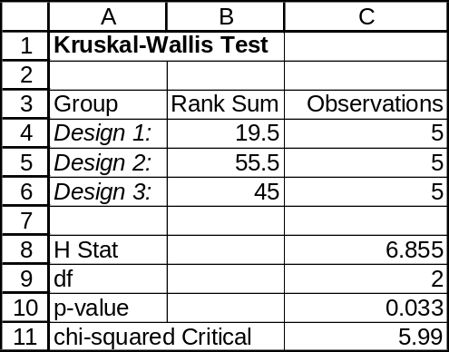

14.32 p/a/m The null and alternative hypotheses are:
H₀: the four formulas are equally effective in promoting plant growth and H₁: at least one formula differs from the others. For this problem, d.f. = 4 - 1 = 3, and the critical value of H (using the chi-square table) at the 0.025 level is 9.348. The Minitab printout is shown below.

Kruskal-Wallis Test: Inches versus Formula

Kruskal-Wallis Test on Inches

Formula N Median Ave Rank Z
1 5 19.000 18.3 2.66
2 6 14.500 11.8 0.11
3 5 8.000 6.0 -2.15
4 6 12.500 10.2 -0.59
Overall 22 11.5

H = 9.33 DF = 3 P = 0.025
H = 9.45 DF = 3 P = 0.024 (adjusted for ties)

Since the adjusted H exceeds the critical value, we reject H₀. Alternatively, we reject H₀ because
p-value = 0.024 is < α = 0.025 level of significance for the test. At this level, there is evidence to suggest that at least one formula exhibits a different level of effectiveness in promoting plant growth than the others.
14.33 p/c/m The null and alternative hypotheses are H₀: the absences are equal across age groups and
H₁: at least one group exhibits a different level of absences. For this problem, d.f. = 3 - 1 = 2, and the critical value of H (using the chi-square table) at the 0.10 level is 4.605. The Minitab printout is below:

Kruskal-Wallis Test: Absences versus AgeGrp

Kruskal-Wallis Test on Absences

AgeGrp N Median Ave Rank Z
1 7 3.000 7.0 -1.58
2 5 8.000 14.1 2.27
3 6 2.500 8.6 -0.52
Overall 18 9.5

H = 5.42 DF = 2 P = 0.066
H = 5.68 DF = 2 P = 0.058 (adjusted for ties)
Since the adjusted H exceeds the critical value, we reject H₀. Alternatively, we reject H₀ because
p-value = 0.058 is < α = 0.10 level of significance for the test. At this level, there is evidence to suggest that at least one age group exhibits a different level of absences.

Using Data Analysis Plus, we obtain the comparable results shown below. Note that the H statistic and
p-value have not been adjusted for ties.
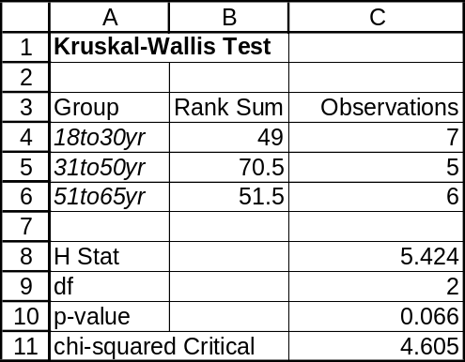

14.34 p/c/m The null and alternative hypotheses are H₀: the three models have the same median fuel economy and H₁: at least one model has a different median fuel economy. For this problem,
d.f. = 3 - 1 = 2, and the critical value of H (using the chi-square table) at the 0.10 level is 4.605.
The Minitab printout is shown below.

Kruskal-Wallis Test: mpg versus Model

Kruskal-Wallis Test on mpg

Model N Median Ave Rank Z
1 5 27.00 11.5 2.14
2 5 22.00 5.2 -1.71
3 5 23.00 7.3 -0.43
Overall 15 8.0

H = 5.15 DF = 2 P = 0.076
H = 5.30 DF = 2 P = 0.071 (adjusted for ties)

Since the adjusted H exceeds the critical value, we reject H₀. Alternatively, we reject H₀ because
p-value = 0.071 is < α = 0.10 level of significance for the test. At this level, there is evidence to suggest that at least one model exhibits a different median fuel economy than the others. Using only the chi-square table, we would find the p-value to be between 0.10 and 0.05.
Using Data Analysis Plus, we obtain the comparable results shown below. Note that the H statistic and
p-value have not been adjusted for ties.
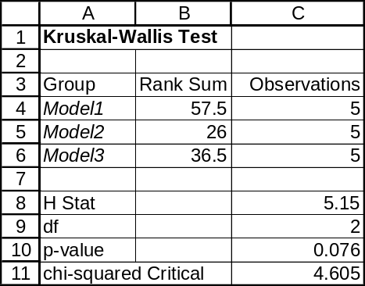

14.35 d/p/m
a. The null and alternative hypotheses for the Friedman test and the randomized block ANOVA are almost identical except that the Friedman test deals with medians and the ANOVA test deals with means.
b. Randomized block ANOVA requires that observations be from normal populations with equal variances and that the observations be measured on the interval or ratio scale. The Friedman test makes no assumptions about the underlying populations, and the observations may be measured on the ordinal, interval, or ratio scale.

14.36 c/a/m The null and alternative hypotheses are H₀: the treatments are equally effective and
H₁: the treatments are not equally effective. For this problem, d.f. = 3 - 1 = 2, and (using the chi-square table) the critical value for F_{r} at the 0.05 level is 5.991. The table below shows the ranks within each block and is used to obtain the calculated F_{r}, which is 4.90.
 | Treatment 1 | Treatment 2 | Treatment 3
Block 1 | 3 | 2 | 1
Block 2 | 1.5 | 3 | 1.5
Block 3 | 3 | 1 | 2
Block 4 | 3 | 2 | 1
Block 5 | 3 | 2 | 1
 | sum = 13.5 | sum = 10.0 | sum = 6.5

The Minitab printout is shown below.

Friedman Test: x versus Treatment, Block

Friedman test for x by Treatmen blocked by Block

S = 4.90 DF = 2 P = 0.086
S = 5.16 DF = 2 P = 0.076 (adjusted for ties)

Est Sum of
Treatmen N Median Ranks
1 5 69.333 13.5
2 5 65.667 10.0
3 5 60.000 6.5

Grand median = 65.000

Since the adjusted F_{r} (shown in the printout as S = 5.16) does not exceed 5.991, we do not reject H₀. Alternatively, we do not reject H₀ because p-value = 0.076 is not < α = 0.05 level of significance for the test. There is no evidence to suggest a difference in the effectiveness of the treatments.

14.37 p/a/m The null and alternative hypotheses are H₀: the median salaries for the three positions are equal and H₁: at least one median differs from the others. For this problem, d.f. = 3 - 1 = 2, and (from the chi-square table) the critical value for F_{r} at the 0.10 level is 4.605. The table below shows the ranks within each block and is used to obtain the calculated F_{r}, which is 3.58.
 | Mayor | Police Chief | Fire Chief
A | 3 | 1 | 2
B | 2 | 1 | 3
C | 3 | 1 | 2
D | 3 | 1.5 | 1.5
E | 3 | 1 | 2
F | 1 | 3 | 2
 | sum = 15 | sum = 8.5 | sum = 12.5

The Minitab printout is shown below.

Friedman Test: Salary versus Position blocked by City

S = 3.58 DF = 2 P = 0.167
S = 3.74 DF = 2 P = 0.154 (adjusted for ties)

Sum of
Position N Est Median Ranks
1 6 115593 15.0
2 6 102275 8.5
3 6 109095 12.5

Grand median = 108987

Since the adjusted F_{r} (shown in the printout as S = 3.74) does not exceed the critical value, we do not reject H₀. Alternatively, we do not reject H₀ because p-value = 0.154 is not < α = 0.10 level of significance for the test. At this level, there is no evidence to suggest a difference in the effectiveness of the treatments. Using only the chi-square table, we would find the p-value to be between 0.10 and 0.90.
Using Data Analysis Plus, we obtain comparable results, although not adjusted for ties.
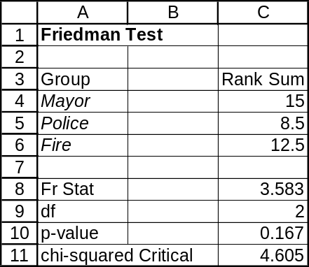

14.38 p/a/m The null and alternative hypotheses are:
H₀: the brands are equally effective in killing ants
H₁: at least one brand differs from the others in median length of time to kill all the ants
For this problem, d.f. = 4 - 1 = 3, and (from the chi-square table) the critical value for F_{r} at the 0.05 level is 7.815. The table below shows the ranks within each block and is used to obtain the calculated F_{r}, which is 9.75.
 | Spray 1 | Spray 2 | Spray 3 | Spray 4
fire ants | 1 | 3 | 2 | 4
bulldog ants | 2 | 3 | 1 | 4
honey ants | 3 | 1 | 2 | 4
carpenter ants | 3 | 1 | 2 | 4
weaver ants | 3 | 2 | 1 | 4
janitor ants | 1 | 2 | 3.5 | 3.5
 | sum = 13 | sum = 12 | sum = 11.5 | sum = 23.5

The Minitab printout is shown below.

Friedman Test: seconds versus spray, typeant

Friedman test for seconds by spray blocked by typeant

S = 9.75 DF = 3 P = 0.021
S = 9.92 DF = 3 P = 0.019 (adjusted for ties)

Est Sum of
spray N Median Ranks
1 6 14.313 13.0
2 6 13.688 12.0
3 6 13.188 11.5
4 6 17.563 23.5

Grand median = 14.688

Since the adjusted F_{r} (shown in the printout as S = 9.92) exceeds the critical value, we reject H₀. Alternatively, we reject H₀ because p-value = 0.019 is < α = 0.05 level of significance for the test.
At this level, there is evidence to suggest a difference in the effectiveness of the brands of pesticide. Using only the chi-square table, we would find the p-value to be between 0.01 and 0.025.

14.39 p/c/m The null and alternative hypotheses are H₀: the median ratings for the three critics are equal and H₁: the median rating given by at least one critic differs from the others. The three critics are considered to be the treatments, and the movies are the blocks. The Minitab printout is shown below.

Friedman Test: Rating versus Critic, Movie

Friedman test for Rating by Critic blocked by Movie

S = 1.75 DF = 2 P = 0.417
S = 1.87 DF = 2 P = 0.393 (adjusted for ties)

Est Sum of
Critic N Median Ranks
1 8 7.833 17.0
2 8 8.167 18.0
3 8 6.500 13.0

Grand median = 7.500

The adjusted F_{r} is shown in the printout as S = 1.87. Because p-value = 0.393 is not < α = 0.025 level of significance for the test., we do not reject H₀. At this level, there is no evidence to suggest a difference in the ratings and/or value systems among the critics.
Using Data Analysis Plus, we obtain comparable results, although not adjusted for ties.
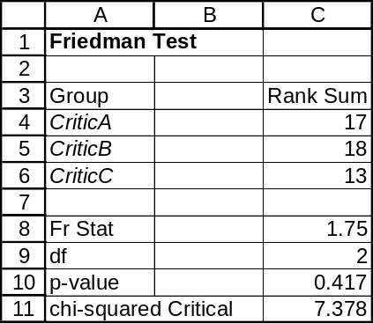

14.40 p/c/m The null and alternative hypotheses are H₀: the slopes are equally difficult and
H₁: at least one slope differs in median difficulty. The three slopes are considered to be the treatments, and the skill levels are the blocks. The Minitab printout is shown below.

Friedman Test: minutes versus Slope, SkillLev

Friedman test for minutes by Slope blocked by SkillLev

S = 8.08 DF = 2 P = 0.018
S = 8.43 DF = 2 P = 0.015 (adjusted for ties)

Est Sum of
Slope N Median Ranks
1 6 4.3833 6.5
2 6 5.3000 16.0
3 6 4.9167 13.5

Grand median = 4.8667

The adjusted F_{r} is shown in the printout as S = 8.43. ) Because p-value = 0.015 is < α = 0.05 level of significance for the test, we reject H₀. At this level, there is evidence to suggest that at least one slope differs from the others in median difficulty.
Using Data Analysis Plus, we obtain comparable results, although not adjusted for ties.
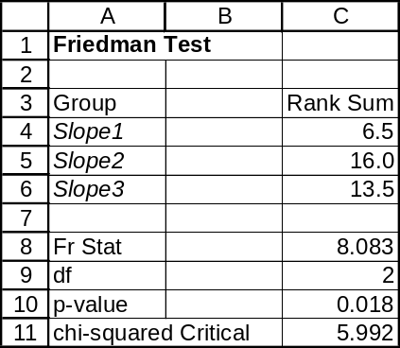

14.41 d/p/e The sign test relies on the fact that, if the true population (of differences) median is equal to zero, there is a 0.50 probability of obtaining a positive difference. Thus, this is a binomial experiment and a difference will be either positive or negative (ties are ignored). When the number of observations (non-zero differences) is at least ten, the normal approximation may be used.

14.42 d/p/e The sign test does not use all of the information contained in the data; the data are merely reduced to (+) and (-) signs, and magnitude is ignored. If the original data are interval in nature, the Wilcoxon signed rank test will provide a more powerful test.

14.43 c/a/m This is a two-tail test. Using the cumulative binomial table in the appendix, we see that the probability of finding 5 or more positive differences when n = 8 is (1 - 0.6367) = 0.3633. Since this is a two-tail test, we multiply this probability by 2, yielding a p-value of 0.7266. Since p-value = 0.7266 is not < α = 0.05 level of significance for the test, we do not reject H₀. There is no evidence to suggest that the median is not zero.

14.44 c/a/m In this right-tail test, p-value = P(S ≥ T). With n = 6, the probability of finding five or more (+) signs is 1 - 0.8906 = 0.1094. Since p-value = 0.1094 is not < α = 0.10 level of significance for the test, we do not reject H₀. There is no evidence to suggest that the median is greater than 20.

14.45 p/a/m Given the data in exercise 14.13, the variable of interest is d = x₁ - x₂. In the earlier exercise, the null and alternative hypotheses are H₀: m_{d} ≤ 0 and H₁: m_{d} > 0. In applying the sign test to these data, we have 9 nonzero differences and 7 of them are positive. We will use Excel worksheet template tmsign. This worksheet template can be used regardless of the number of nonzero differences, because it relies on the binomial distribution, and is not an approximation.
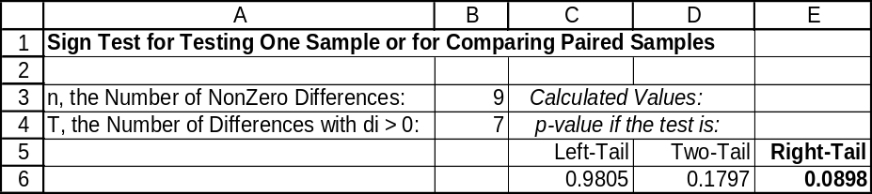

The p-value for this right-tail test is 0.0898, which is < α = 0.10 level of significance for the test, and we reject H₀. This conclusion is the same as in exercise 14.13, although the p-value for the sign test is not quite as low as that for the Wilcoxon signed rank test (0.087) performed earlier. Because these data are at least interval in nature, the Wilcoxon signed rank test (which uses more of the information contained in the data) is the more powerful of the two tests. The corresponding Minitab printout is shown below.

Sign Test for Median: diff

Sign test of median = 0.00000 versus > 0.00000

N Below Equal Above P Median
diff 9 2 0 7 0.0898 0.5000

14.46 p/a/m In exercise 14.8, the null and alternative hypotheses are H₀: M = 10 hours and
H₁: M ≠ 10 hours. In applying the sign test to these data, we have 18 nonzero differences and 3 of them are positive. We will use Excel worksheet template tmsign. This worksheet template can be used regardless of the number of nonzero differences, because it relies on the binomial distribution, and is not an approximation.
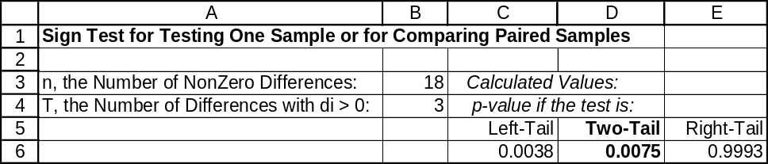

The p-value for this two-tail test is 0.0075, which is < α = 0.05 level of significance for the test, and we reject H₀. This conclusion is the same as in exercise 14.8, although the p-value for the sign test is not quite as low as that for the Wilcoxon signed rank test (0.004) performed earlier. Because these data are at least interval in nature, the Wilcoxon signed rank test (which uses more of the information contained in the data) is the more powerful of the two tests. The corresponding Minitab printout is shown below.

Sign Test for Median: hours

Sign test of median = 10.00 versus not = 10.00

N Below Equal Above P Median
hours 20 15 2 3 0.0075 8.500

14.47 d/p/e A "run" is a sequence of like events or the consecutive appearance of one or more observations that are similar.

14.48 c/p/e The number of runs in each series is:
a. 17 b. 20 c. 17 d. 2

14.49 p/a/m The null and alternative hypotheses are H₀: the sequence is random and H₁: the sequence is not random. The data can be divided into two categories, above 1.5 and below 1.5.
The Minitab printout is shown below.

Runs Test: NamCode

NamCode

K = 1.5000

The observed number of runs = 18
The expected number of runs = 17.6111
13 Observations above K 23 below
The test is significant at 0.8864
Cannot reject at alpha = 0.05

Since p-value = 0.8864 is not < α = 0.10 level of significance for this test, we do not reject H₀. There is no evidence to suggest that the sequence is not random. For this problem, we can also use Excel worksheet template tmruns. There are 18 runs in the 36-year series, with 13 observations above 1.5 and 23 below 1.5. The p-value in this approximation is, to four decimal places, the same as the value generated by Minitab, above.
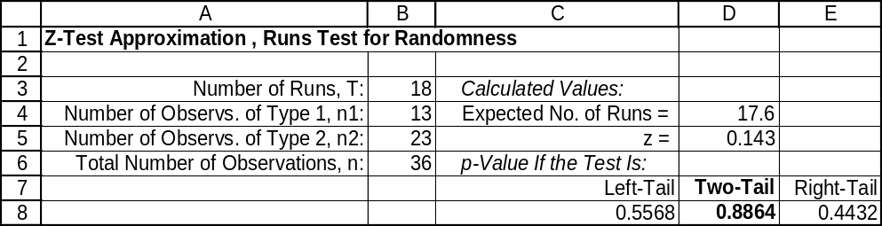

14.50 p/a/m The null and alternative hypotheses are H₀: the sequence is random and H₁: the sequence is not random. For purposes of computer analysis, the "F" data are assigned a value of 1, and the "M" data are assigned a value of 0. The Minitab printout is shown below.

Runs Test: gender

gender

K = 0.5000
The observed number of runs = 17
The expected number of runs = 12.6667
10 Observations above K 14 below
The test is significant at 0.0628
Cannot reject at alpha = 0.05

Since p-value = 0.0628 is < α = 0.10 level of significance for this test, we reject H₀. There is evidence to suggest that the sequence of surprise visits is not random. For this problem, we can also use Excel worksheet template tmruns. There are 17 runs in the 24-visit series, with 10 observations above 0.5 and 14 below 0.5. The p-value in this approximation is very close to the value generated by Minitab, above.
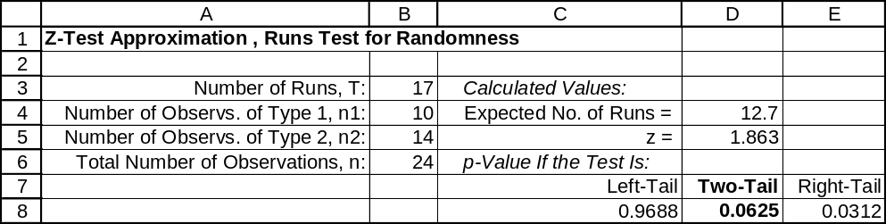

14.51 p/a/m The null and alternative hypotheses are H₀: the data are from a normal distribution and
H₁: the data are not from a normal distribution. For the sample values, the mean and standard deviation are 152.5 and 10.88905, respectively, and they are used to estimate their population counterparts.
As an example of the calculations involved, the z value corresponding to the test score of 145 can be calculated as z = (145 - 152.5)/10.88905, or z = -0.69.
The expected cumulative relative frequencies can then be determined using the standard normal distribution table. For example, the expected cumulative relative frequency associated with the test score of 145 would be 0.2451. Because there are 8 observations and we are using the 0.10 level of significance, the critical value of D is 0.261. Therefore, we will reject H₀ if D_{max} > 0.261.
Data | z | rel. freq. | cum. freq. | expected | | D |
142 | -0.96 | 0.125 | 0.125 | 0.1685 | 0.0435
142 | -0.96 | 0.125 | 0.250 | 0.1685 | 0.0815
145 | -0.69 | 0.125 | 0.375 | 0.2451 | 0.1299
147 | -0.51 | 0.125 | 0.500 | 0.3050 | 0.1950
149 | -0.32 | 0.125 | 0.625 | 0.3745 | 0.2505
161 | 0.78 | 0.125 | 0.750 | 0.7823 | 0.0323
164 | 1.06 | 0.125 | 0.875 | 0.8554 | 0.0196
170 | 1.61 | 0.125 | 1.000 | 0.9463 | 0.0537
Since the largest absolute value of D (0.2505) is less than the critical value (0.261), we do not reject H₀. At the 0.10 level, there is no evidence to suggest that the data are not from a normal distribution. Using the table of critical values for the Kolmogorov-Smirnov test, we can determine that the p-value for this test is between 0.10 and 0.15.

The corresponding Minitab Kolmogorov-Smirnov results are shown below. The p-value for the test of normality is shown as 0.141, and this is not less than the 0.10 level of significance used to reach a conclusion; thus, the null hypothesis of normality can not be rejected.
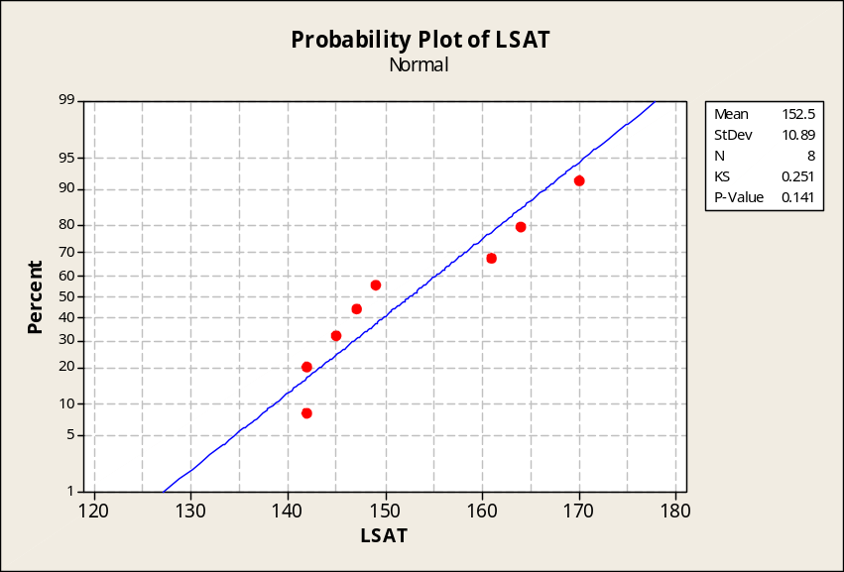

14.52 p/a/m This test can be performed with pocket calculator, formulas and tables, as we showed in the solution to exercise 14.51, but we will use Minitab. The null and alternative hypotheses are H₀: the data are from a normal distribution and H₁: the data are not from a normal distribution. Because there are 5 observations and we are using the 0.05 level of significance, the critical value of D is 0.337. Therefore, we will reject H₀ if D_{max} > 0.337. Referring to the printout below, KS, or D_{max} = 0.336 is slightly less than the critical value of 0.337, and we do not reject H₀. At this level, the data could have come from a normal distribution. Minitab lists an approximate p-value of 0.062.
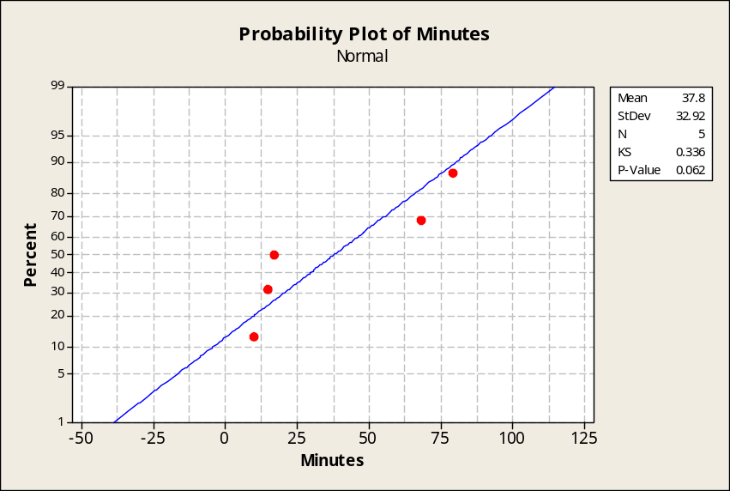

14.53 p/a/m This test can be performed with pocket calculator, formulas and tables, as we showed in the solution to exercise 14.51, but we will use Minitab. The null and alternative hypotheses are H₀: the data are from a normal distribution and H₁: the data are not from a normal distribution. Because there are 7 observations and we are using the 0.10 level of significance, the critical value of D is 0.276. Therefore, we will reject H₀ if D_{max} > 0.276. Referring to the Minitab printout below, KS, or D_{max} = 0.224 is less than the critical value of 0.276, and we do not reject H₀. At this level, the data could have come from a normal distribution. Minitab shows the approximate p-value as greater than 0.15.
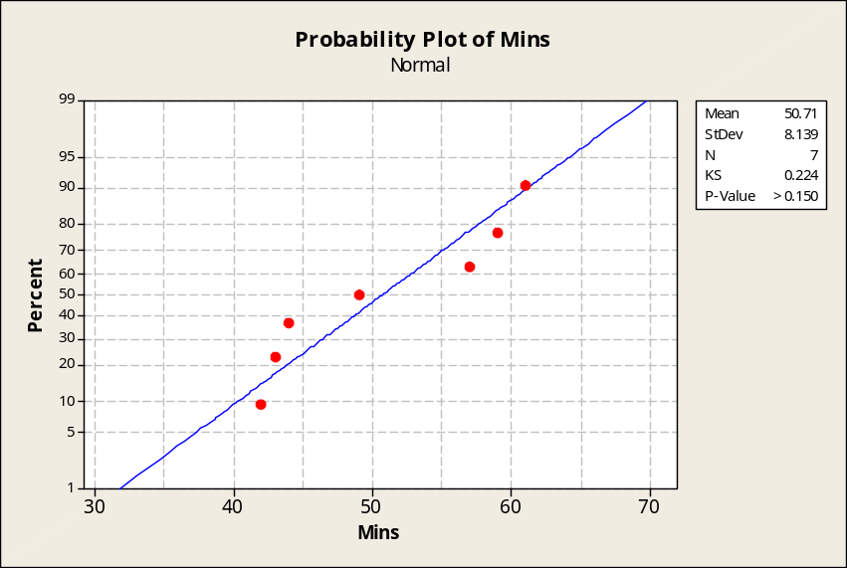

14.54 d/p/e The Spearman coefficient of rank correlation is a measure of the strength and directionality of the relationship between two variables that are at least ordinal. The possible values are between -1.0 and +1.0. Positive values indicate a direct relationship, while negative values indicate an inverse relationship between the variables.

14.55 p/a/m For this situation, the Spearman coefficient of rank correlation will be
r_{s} = 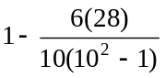 = 0.83. In a two-tail test at the 0.05 level, the critical values are -0.648 and +0.648. The calculated coefficient (0.83) falls outside this region and, at the 0.05 level, we conclude that the Spearman coefficient of rank correlation differs significantly from 0 for these two travel editors.

14.56 p/a/m
Conversion to ranks for the husbands and wives results in the following:
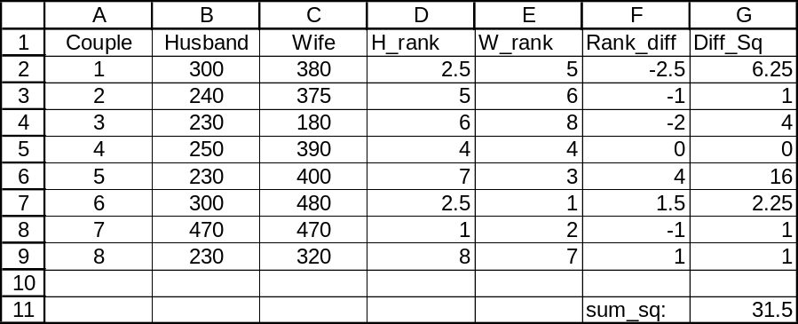

The Spearman rank order of correlation between the ranks is 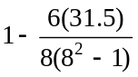 = 1 - 0.375 = 0.625.
For n = 8 pairs and a two-tail test at the 0.05 level, critical values of r_{s} are -0.738 and 0.738.
The calculated value falls within the nonrejection region and we are unable to reject the possibility that the true rank correlation could be 0.

14.57 p/a/m
The underlying calculations lead to the following results:
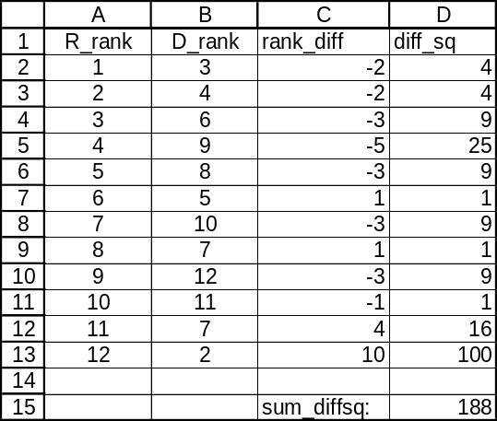

The Spearman rank order of correlation between the ranks is 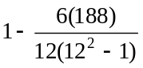 = 1 - 0.657 = 0.343.
For n = 12 pairs and a two-tail test at the 0.02 level, critical values of r_{s} are -0.703 and +0.703.
The calculated value falls within the nonrejection region and we are unable to reject the possibility that the true rank correlation could be 0. However, the presence of a lot of ties within the ranks makes our result more approximate than if this had not been the case.

14.58 p/c/m The variable of interest is the difference between the before and after cholestrol levels, or
d = x₁ - x₂. The null and alternative hypotheses are H₀: m_{d} ≤ 0 and H₁: m_{d} > 0. The Minitab and Data Analysis Plus results are shown below. Note that Data Analysis Plus has used a normal approximation to the sign test. For this right-tail test, p-value = 0.0001 is less than the 0.025 level of significance for the test, and we reject H₀. It is apparent that the diet and exercise program is effective in reducing cholestrol. An important note: Although the program is obviously effective in reducing cholestrol, it does not seem to reduce cholestrol by very much. Most physicians would not consider a reduction of 0.900 cholesterol points to be a very useful reduction in terms of reducing the risk of heart disease.

Sign Test for Median: Diff

Sign test of median = 0.00000 versus > 0.00000

N Below Equal Above P Median
Diff 40 6 5 29 0.0001 0.9000

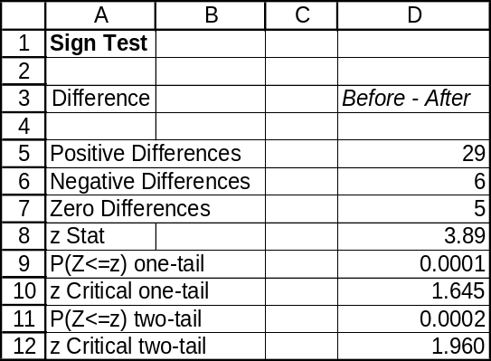

14.59 p/c/m The null and alternative hypotheses are H₀: M_{d} ≥ 9 and H₁: M_{d} < 9. The Minitab and Data Analysis Plus results are shown below. Note that Data Analysis Plus has used a normal approximation to the sign test. For this left-tail test, p-value = 0.0287 is less than the 0.05 level of significance for the test, and we reject H₀. We conclude that the median age for cars driven to work by the company’s executives is less than 9 years.

Sign Test for Median: Age

Sign test of median = 9.000 versus < 9.000

N Below Equal Above P Median
Age 15 11 1 3 0.0287 6.000

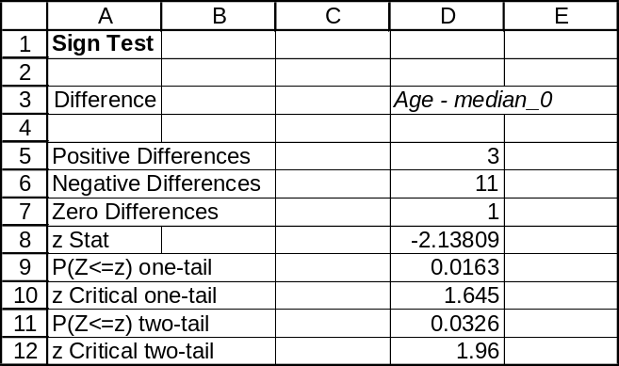

14.60 p/c/m The null and alternative hypotheses are H₀: the sequence is random and H₁: the sequence is not random. The Minitab printout is shown below. Because p-value = 0.045 is less than the 0.05 level of significance for the test, we reject H₀ and conclude that the sequence is other than random. At this level, there are more “streaks” than we are willing to attribute to chance, and the sequence is not random.

Runs Test: Winner

Runs test for Winner

Runs above and below K = 1.5

The observed number of runs = 16
The expected number of runs = 22.4884
22 observations above K, 21 below
P-value = 0.045

14.61 p/c/m The null and alternative hypotheses are H₀: the sequence is random and H₁: the sequence is not random. The Minitab printout is shown below and the default cutoff is the mean winning margin (14.79 points). Because p-value = 0.619 is not less than the 0.10 level of significance for the test,
we do not reject H₀. At this level, the sequence of winning margins could be random.

Runs Test: Margin

Runs test for Margin

Runs above and below K = 14.7907

The observed number of runs = 24
The expected number of runs = 22.3953
20 observations above K, 23 below
P-value = 0.619

14.62 p/c/m The null and alternative hypotheses are H₀: the data are from a normal distribution and
H₁: the data are not from a normal distribution. The Minitab printout is immediately below. The calculated Kolmogorov-Smirnov statistic is 0.108, which is less than the critical value of 0.135.
Minitab lists the approximate p-value as >0.15 and, at the 0.05 level, we are not able to reject the possibility that the data could have come from a normal distribution.
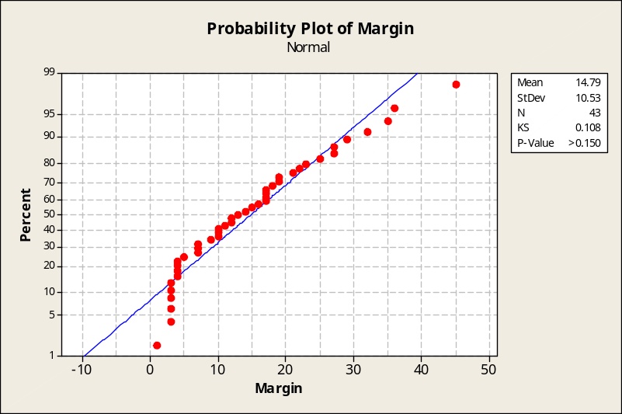

The results of the Data Analysis Plus chi-square test for normality are shown below.
Because p-value = 0.172 is not less than the 0.05 level of significance used in the test, we are not able to reject the possibility that the data could have come from a normal distribution.
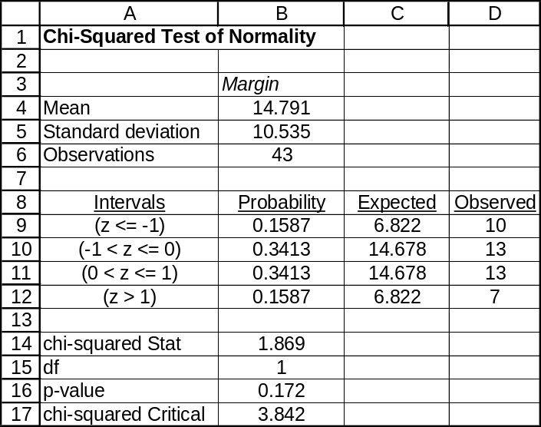

14.63 p/c/m The null and alternative hypotheses are H₀: the data are from a normal distribution and
H₁: the data are not from a normal distribution.For 50 observations, we refer to the appendix table and determine the critical value of D for the 0.10 level as 0.114. The calculated Kolmogorov-Smirnov statistic, or D_{max}, is shown as 0.069. This is less than the critical value, and we do not reject H₀.
At this level, the rates of return could have come from a normal distribution.
Minitab lists the p-value as >0.150.
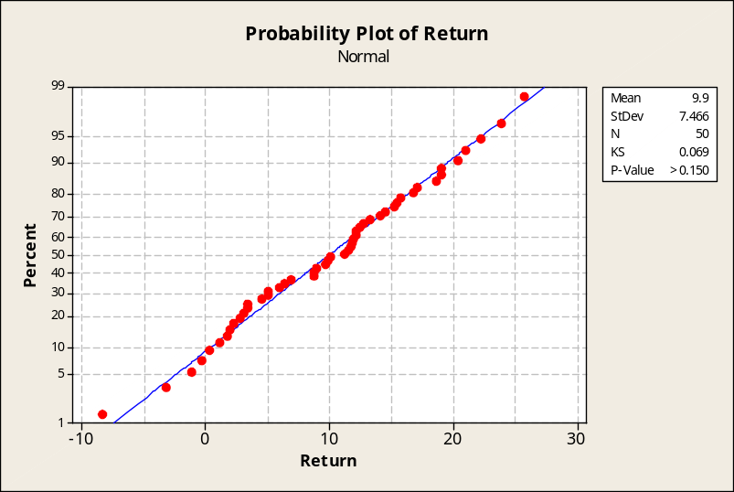

The results of the Data Analysis Plus chi-square test for normality are shown below.
Because p-value = 0.505 is not less than the 0.10 level of significance used in the test,
we conclude that the data could have come from a normal distribution.
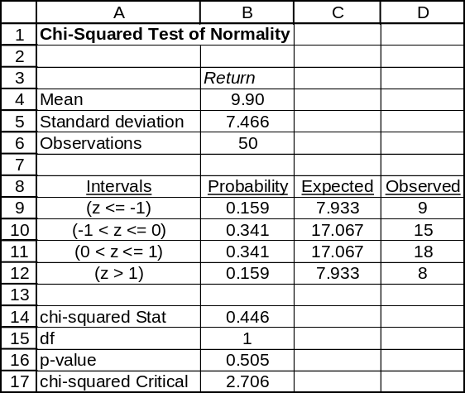

CHAPTER EXERCISES
14.64 p/a/m The Wilcoxon signed rank test for paired samples is appropriate for this problem.
The null and alternative hypotheses are H₀: the formulas are equally effective and H₁: the formulas are not equally effective. This is a two-tail test. For the 0.05 level of significance with n = 10, the critical values of W are 9 and 46. The Minitab printout is shown below.

Wilcoxon Signed Rank Test: diff

Test of median = 0.000000 versus median not = 0.000000
N for Wilcoxon Estimated
N Test Statistic P Median
diff 10 10 10.0 0.083 -2.000

The calculated value of W is between the critical values, so we do not reject H₀. At the 0.05 level, there is no evidence to suggest that the formulas are not equally effective. Alternatively, p-value = 0.083 is not < α = 0.05 level of significance for the test, and we do not reject H₀. Using only the critical values table for the Wilcoxon signed rank test, we see that the p-value for this problem is between 0.05 and 0.10.

14.65 p/a/m The Wilcoxon rank sum test is appropriate for this problem. The null and alternative hypotheses are H₀: M_{A} ≤ M_{B} and H₁: M_{A} > M_{B}. In this right-tail test at the 0.05 level, the critical value of W is 127. The Minitab printout is shown below.

Mann-Whitney Test and CI: BrandA, BrandB

N Median
BrandA 10 93.85
BrandB 10 81.60

Point estimate for ETA1-ETA2 is 18.70
95.5 Percent CI for ETA1-ETA2 is (1.81,30.81)
W = 139.0
Test of ETA1 = ETA2 vs ETA1 > ETA2 is significant at 0.0057
The test is significant at 0.0056 (adjusted for ties)

Since W = 139.0 exceeds 127, we reject H₀ at the 0.05 level. Alternatively, we reject H₀ because
p-value = 0.0056 is < α = 0.05 level of significance for the test. At the 0.05 level, evidence suggests
that brand A is superior to brand B. Using only the Wilcoxon rank sum test critical values table in the text, we could determine that p-value < 0.025.

Because each sample size is at least 10, we can also use Data Analysis Plus and the normal approximation to the Wilcoxon rank sum test. The results are comparable and the printout is
shown below.
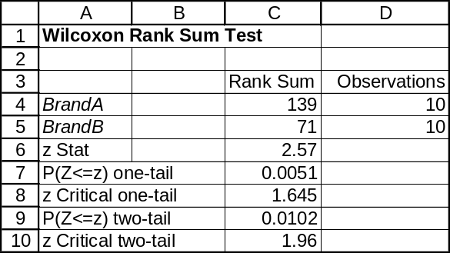

14.66 p/a/m The one-sample Wilcoxon signed rank test is appropriate for this problem. The null and alternative hypotheses are H₀: M ≥ $295.2 thousand and H₁: M < $295.2 thousand. With n = 10 and a left-tail test at the 0.025 level, the critical value of W is 9. The Minitab printout is shown below.

Wilcoxon Signed Rank Test: price

Test of median = 295.2 versus median < 295.2

N for Wilcoxon Estimated
N Test Statistic P Median
price 10 10 11.0 0.051 284.2

Since the W = 11.0 is not less than 9, we do not reject H₀. There is no evidence, at the 0.025 level,
to suggest that the median price of new homes is less than $295,200. Alternatively, since p-value = 0.051 is not < α = 0.025 level of significance for the test, we do not reject H₀. Using only the Wilcoxon signed rank test critical values table in the text, we could determine the p-value for this test to be between 0.05 and 0.10.

14.67 p/a/m The Wilcoxon signed rank test is appropriate here. The null and alternative hypotheses are H₀: the median pulse rate is unchanged and H₁: the median pulse rate has changed. This is a two-tail test. With n = 6, critical values of W at the 0.05 level are 1 and 20. Considering the difference between before and after pulse rates as the variable of interest, the Minitab printout is shown below.

Wilcoxon Signed Rank Test: diff

Test of median = 0.000000 versus median not = 0.000000
N for Wilcoxon Estimated
N Test Statistic P Median
diff 6 6 19.5 0.075 4.000

Since the calculated value of W falls between the critical values, we do not reject H₀. At the 0.05 level, there is no evidence to suggest that the exercise program has affected resting pulse rates. Alternatively, since p-value = 0.075 is not < α = 0.05 level of significance for the test, we do not reject H₀. Using only the table of critical values for the Wilcoxon signed rank test, we could determine the p-value to be between 0.05 and 0.10.

14.68 p/a/m The Kruskal-Wallis test is appropriate for this problem. The null and alternative hypotheses are H₀: the seat designs do not differ in staying times and H₁: at least one seat design has a different staying time. With three groups, the d.f. value for the chi-square approximation is 3 - 1 = 2. The critical value of H at the 0.05 level is 5.991. The Minitab printout is shown below.

Kruskal-Wallis Test: minutes versus Design

Kruskal-Wallis Test on minutes

Design N Median Ave Rank Z
1 6 7.000 4.8 -2.62
2 6 11.000 10.8 0.75
3 6 12.500 12.8 1.87
Overall 18 9.5

H = 7.30 DF = 2 P = 0.026
H = 7.46 DF = 2 P = 0.024 (adjusted for ties)

Since the calculated value of H (adjusted for ties) exceeds the critical value, we reject H₀. At the 0.05 level, there is evidence to suggest that at least one of the seat designs has a different median staying time. Alternatively, since p-value = 0.024 is < α = 0.05 level of significance for the test, we reject H₀. Using only the chi-square table, we could determine that the p-value for this problem is between 0.025 and 0.01.

Using Data Analysis Plus, we obtain the comparable results shown below. Note that the H statistic and
p-value have not been adjusted for ties.
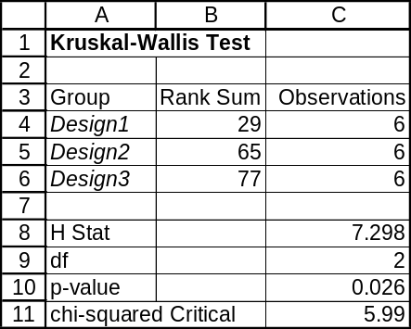

14.69 p/a/m The Friedman test is appropriate for this problem. The null and alternative hypotheses are H₀: the medians are equal for each of the compactors and H₁: at least one median differs.
Using the chi-square approximation for F_{R}, the appropriate degrees of freedom are 5 - 1 = 4. At the 0.025 level, the critical value of F_{R} is 11.143. The table below shows the basic calculations leading to F_{R}.
 | comp 1 | comp 2 | comp 3 | comp 4 | comp 5
cans & bottles | 1 | 2 | 3 | 5 | 4
cardboard boxes | 1.5 | 1.5 | 4.5 | 4.5 | 3
newspapers & mags | 1 | 2 | 3 | 5 | 4
 | sum = 3.5 | sum = 5.5 | sum = 10.5 | sum = 14.5 | sum = 11.0

The calculated F_{R} = 10.53 is less than the critical value, and we do not reject H₀. At the 0.025 level, there is no evidence to suggest that the compactors are not equally effective. Using only the chi-square table, we could find the p-value for this test to be between 0.025 and 0.05. The Minitab printout is shown below and the p-value (adjusted for ties) is 0.028. Since p-value = 0.028 is not < α = 0.025 level of significance for the test, we do not reject H₀. The Minitab printout is shown below.

Friedman Test: CubeFt versus Comp, Block

Friedman test for CubeFt by Comp blocked by Block

S = 10.53 DF = 4 P = 0.032
S = 10.90 DF = 4 P = 0.028 (adjusted for ties)

Est Sum of
Comp N Median Ranks
1 3 1.4000 3.5
2 3 1.5000 5.5
3 3 1.6600 10.5
4 3 1.8200 14.5
5 3 1.7200 11.0
Grand median = 1.6200

Using Data Analysis Plus, we obtain the comparable results (without adjustment for ties) shown below.
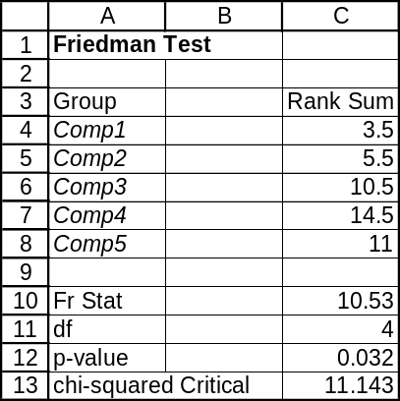

14.70 p/a/m The Kruskal-Wallis test is appropriate for this problem. The null and alternative hypotheses are H₀: the photos are equally effective and H₁: at least one differs in its effectiveness.
Using the chi-square approximation for H, d.f. = 4 - 1 = 3 and the critical value of H at the 0.01 level is 11.345. The Minitab printout is shown below.

Kruskal-Wallis Test: Custs versus Photo

Kruskal-Wallis Test on Custs

Photo N Median Ave Rank Z
1 6 34.50 13.9 0.81
2 6 31.00 11.6 -0.18
3 5 22.00 7.5 -1.68
4 6 30.50 14.3 0.95
Overall 23 12.0

H = 3.36 DF = 3 P = 0.339
H = 3.37 DF = 3 P = 0.338 (adjusted for ties)

Since the calculated value of H (adjusted for ties) is less than the critical value, we do not reject H₀.
At the 0.01 level, there is no evidence to suggest that the photos are not equally effective. Alternatively,
p-value = 0.338 is not < α = 0.01 level of significance for the test, and we do not reject H₀. Using only the chi-square table, we could determine that the p-value for this problem is between 0.10 and 0.90.
The comparable Data Analysis Plus result (without adjustment for ties) is shown below.
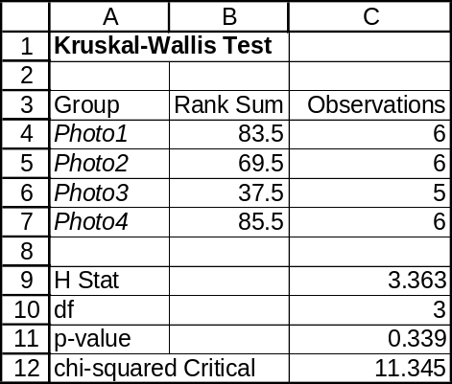

14.71 p/a/m The Friedman test is appropriate for this problem. The null and alternative hypotheses are H₀: the shapes are equally effective and H₁: at least one shape differs in effectiveness.
Using the chi-square approximation for F_{R}, d.f. = 3 - 1 = 2 and the critical value of F_{R} at the 0.025 level is 7.378. The table below shows the basic calculations leading to F_{R}.
 | o-ring 1 | o-ring 2 | o-ring 3
86 degrees | 3 | 2 | 1
75 degrees | 2 | 3 | 1
65 degrees | 2 | 3 | 1
55 degrees | 3 | 2 | 1
45 degrees | 3 | 2 | 1
33 degrees | 3 | 1 | 2
 | sum = 16 | sum = 13 | sum = 7

The calculated F_{R} = 7.00 is less than the critical value, and we do not reject H₀. At the 0.025 level, there is no evidence to suggest that the o-ring shapes are not equally effective. Using only the chi-square table, we could find the p-value for this test to be between 0.025 and 0.05. The Minitab printout is shown below. Since p-value = 0.030 is not < α = 0.025 level of significance for the test, we do not reject H₀.

Friedman Test: Pressure versus Shape, Temp

Friedman test for Pressure by Shape blocked by Temp

S = 7.00 DF = 2 P = 0.030

Est Sum of
Shape N Median Ranks
1 6 12.892 16.0
2 6 12.525 13.0
3 6 10.908 7.0

Grand median = 12.108

Using Data Analysis Plus, we obtain the comparable results shown below.
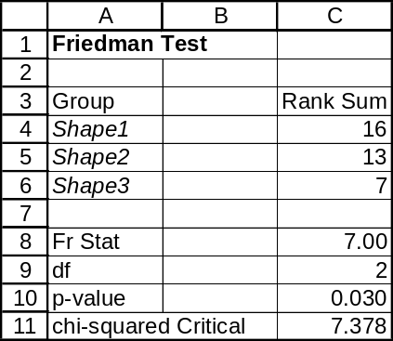

14.72 p/a/m The sign test is appropriate for this problem. For d = x_{pre} - x_{post}, the null and alternative hypotheses are H₀: M_{d} ≥ 0 and H₁: M_{d} < 0. Subtracting the post-course rating from the pre-course rating yields eight negative observations out of the nine. The probability of finding eight or more negative observations with n = 9 and π = 0.5 is 1 - 0.9805 = 0.0195. This is shown in the Minitab printout below.

Sign Test for Median: diff

Sign test of median = 0.00000 versus < 0.00000

N Below Equal Above P Median
diff 12 8 3 1 0.0195 -1.000

Because p-value = 0.0195 is < α = 0.05 level of significance for the test, we reject H₀. At this level, there is evidence to suggest that there has been a significant improvement in the ratings received by the instructor.

We can also use the sign test and Excel worksheet template tmsign. This worksheet template can be used regardless of the number of nonzero differences, because it relies on the binomial distribution, and is not an approximation. In using this template, we input the number of nonzero differences (9) and the number of positive differences (1).
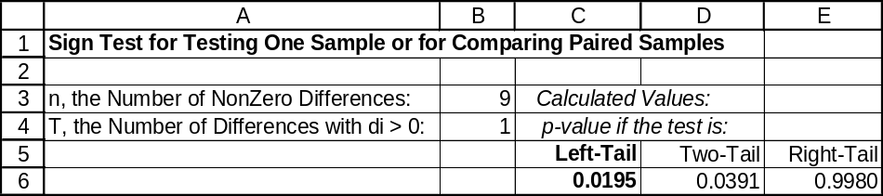

14.73 p/a/m The answers will vary widely with the data collected for this particular exercise.
It might also be interesting to compare data for the same location at different times of the day or for different days of the week.

14.74 p/a/m Applying the runs test to this problem, the null and alternative hypotheses are
H₀: the sequence is random and H₁: the sequence is not random. We will assign a value of 1 for college graduates and a value of 0 for nongraduates. The Minitab printout is shown below.

Runs Test: Grad

Grad

K = 0.5000

The observed number of runs = 21
The expected number of runs = 15.9333
14 Observations above K 16 below
The test is significant at 0.0586
Cannot reject at alpha = 0.05

Since p-value = 0.0586 < α = 0.10 level of significance for this test, we reject H₀. There is evidence to suggest that the sequence of interviewees is not random. For this problem, we can also use Excel worksheet template tmruns. There are 21 runs in the 30-item series, with 14 observations above 0.5 and 16 below 0.5. The p-value in this approximation is comparable to the value generated by Minitab, above.
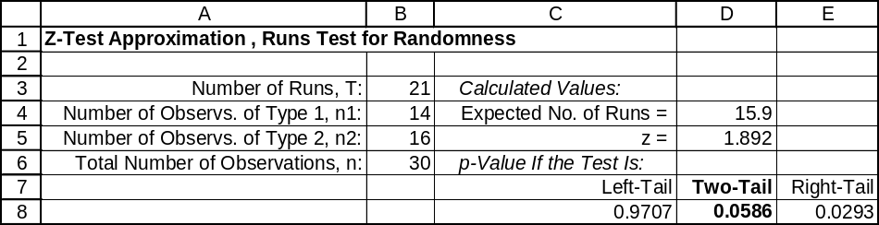

14.75 p/a/m Applying the Wilcoxon signed rank test to this problem, the null and alternative hypotheses will be H₀: M ≤ 20 and H₁: M > 20. For this right-tail test with n = 10 and using the 0.05 level, the critical value of W is 44. The Minitab printout is shown below.

Wilcoxon Signed Rank Test

Test of median = 20.00 versus median > 20.00
N for Wilcoxon Estimated
N Test Statistic P Median
time 10 10 45.0 0.042 22.20

Since the calculated value of W exceeds the critical value, we reject H₀. At the 0.05 level, there is evidence to suggest that the median travel time is more than twenty minutes. Alternatively, since p-value = 0.042 is < α = 0.05 level of significance for the test, we reject H₀. Using only the table of critical values for the Wilcoxon signed rank test, we could determine that the p-value is between 0.05 and 0.025.

14.76 p/a/m The null and alternative hypotheses are H₀: the data are from a normal distribution and
H₁: the data are not from a normal distribution. There are n = 5 observations, so the critical value of D for the 0.10 level of significance is 0.315. The observed Kolmogorov-Smirnov statistic, KS = D_{max} = 0.360 exceeds the critical value of 0.315 for the 0.10 level of significance and we reject H₀. At this level, the times have not come from a normal distribution. Minitab lists the approximate p-value as 0.039.
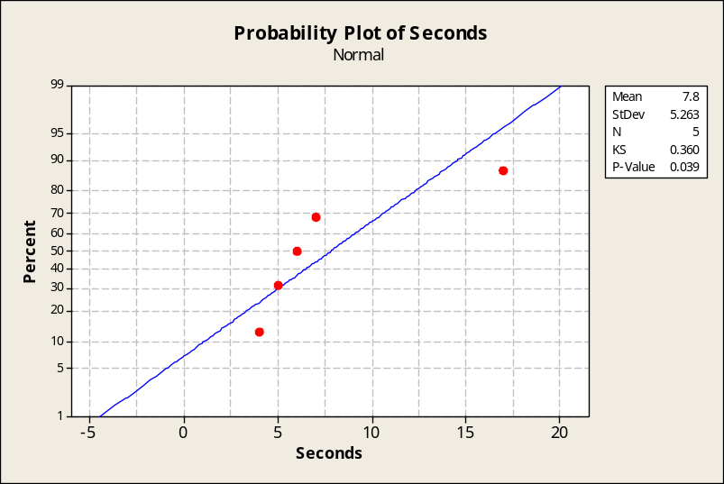

14.77 p/a/m
The underlying calculations lead to the following results:
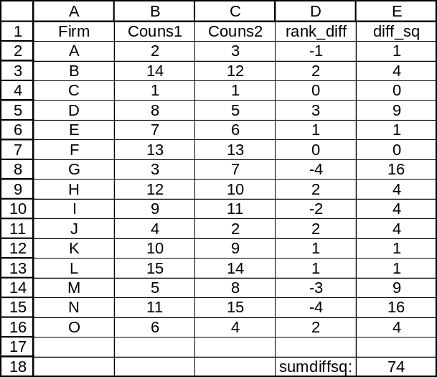

The Spearman rank order of correlation between the ranks is 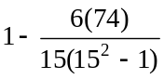 = 1 - 0.132 = 0.868.
For n = 15 pairs and a two-tail test at the 0.05 level, critical values of r_{s} are -0.525 and +0.525.
The calculated value falls into a rejection region and we reject the possibility that the true rank correlation could be 0.

14.78 p/c/m Applying the Wilcoxon signed rank test, the null and alternative hypotheses are
H₀: M = 12.5 ounces and H₁: M ≠ 12.5 ounces. The Minitab printout is shown below.

Wilcoxon Signed Rank Test: Ounces

Test of median = 12.50 versus median not = 12.50
N for Wilcoxon Estimated
N Test Statistic P Median
Ounces 7 6 2.0 0.093 12.05

Since p-value = 0.093 is < α = 0.10 level of significance for the test, we reject H₀. At the 0.10 level, there is evidence to suggest that the machine has "drifted" from its desired setting.

14.79 p/c/m Applying the Wilcoxon signed rank test, the null and alternative hypotheses are
H₀: M_{d} ≥ 0 and H₁: M_{d} < 0. The Minitab printout is shown below.

Wilcoxon Signed Rank Test: diff

Test of median = 0.000000 versus median < 0.000000
N for Wilcoxon Estimated
N Test Statistic P Median
diff 5 5 5.5 0.343 -2.000

Since p-value = 0.343 is not < α = 0.05 level of significance for the test, we do not reject H₀. At the 0.05 level, there is no evidence to suggest that the incentive policy has improved performance.

14.80 p/c/m Applying the Wilcoxon signed rank test for paired samples and, for the six tasks,
d = the time required by applicant 1 minus the time required by applicant 2, the null and alternative hypotheses are H₀: m_{d} = 0 and H₁: m_{d} ≠ 0. The Minitab printout is shown below.

Wilcoxon Signed Rank Test: diff

Test of median = 0.000000 versus median not = 0.000000
N for Wilcoxon Estimated
N Test Statistic P Median
diff 6 6 21.0 0.036 0.8500

Since p-value = 0.036 is < α = 0.10 level of significance for the test, we reject H₀. At the 0.10 level, there is evidence to suggest that the applicants are not equally qualified.

14.81 p/c/m Applying the Wilcoxon rank sum test, the null and alternative hypotheses are H₀: the two routes are equally efficient and H₁: the routes are not equally efficient. The Minitab printout is shown below.

Mann-Whitney Test and CI: RouteA, RouteB

RouteA N = 5 Median = 19.000
RouteB N = 5 Median = 21.100
Point estimate for ETA1-ETA2 is -2.700
96.3 Percent CI for ETA1-ETA2 is (-7.502,1.600)
W = 21.0
Test of ETA1 = ETA2 vs ETA1 not = ETA2 is significant at 0.2101

Cannot reject at alpha = 0.05

Since p-value = 0.2101 is not < α = 0.05 level of significance for the test, we do not reject H₀. At the 0.05 level, there is no evidence to suggest that the two routes are not equally efficient.

14.82 p/c/m Applying the Kruskal-Wallis test, the null and alternative hypotheses are H₀: the customer ratings are equal for the restaurants and H₁: at least one restaurant differs from the others.
The Minitab printout is shown below.

Kruskal-Wallis Test: Rating versus Restrnt

Kruskal-Wallis Test on Rating

Restrnt N Median Ave Rank Z
1 8 69.50 7.9 -2.27
2 8 81.00 17.4 2.42
3 8 75.00 12.2 -0.15
Overall 24 12.5

H = 7.34 DF = 2 P = 0.025
H = 7.38 DF = 2 P = 0.025 (adjusted for ties)

Since p-value = 0.025 is < α = 0.05 level of significance for the test, we reject H₀. At the 0.05 level, there is evidence to suggest that the population median ratings for the three restaurants are not the same. The corresponding Data Analysis Plus printout (without adjustment for ties) is shown below.
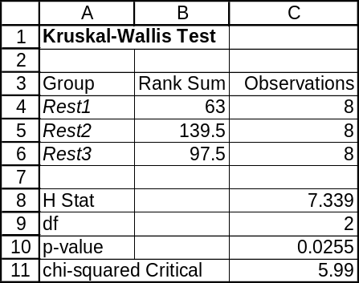

14.83 p/c/m Applying the Friedman test, the null and alternative hypotheses are H₀: the rankings are equal across price ranges and H₁: the rankings for at least one price range differ. The Minitab printout is shown below.

Friedman Test: Rating versus Price, Taster

Friedman test for Rating by Price blocked by Taster

S = 7.90 DF = 2 P = 0.019
S = 8.32 DF = 2 P = 0.016 (adjusted for ties)

Est Sum of
Price N Median Ranks
1 5 4.000 5.0
2 5 8.333 11.5
3 5 9.667 13.5

Grand median = 7.333

Since p-value = 0.016 is < α = 0.05 level of significance for the test, we reject H₀. At the 0.05 level, there is evidence to suggest that the rankings do differ across price ranges -- i.e., it appears the tasters can tell the difference between cheaper and more expensive wines. The corresponding Data Analysis Plus printout (without adjustment for ties) is shown below.
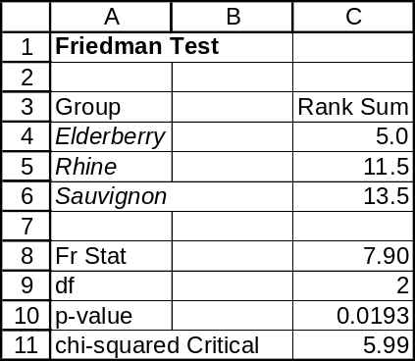

14.84 p/c/m Applying the Friedman test, the null and alternative hypotheses are H₀: the workstations' arrangements are equally comfortable and H₁: at least one workstation differs from the others in terms of comfort. The Minitab printout is shown below.

Friedman Test: Comfort versus Arrangmt, Operator

Friedman test for Comfort by Arrangmt blocked by Operator

S = 8.76 DF = 3 P = 0.033

Est Sum of
Arrangmt N Median Ranks
1 5 8.750 18.0
2 5 8.500 15.0
3 5 5.500 10.0
4 5 3.250 7.0

Grand median = 6.500

Since p-value = 0.033 is < α = 0.05 level of significance for the test, we reject H₀. At the 0.05 level, there is evidence to suggest that at least one workstation differs in comfort. The corresponding Data Analysis Plus printout is shown below.
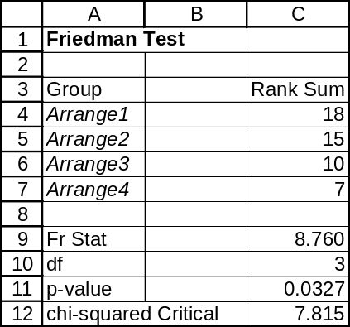

14.85 p/c/m Applying the runs test, the null and alternative hypotheses are H₀: the sequence is random and H₁: the sequence is not random. The median for the data is 38.0. To ensure that the median value is included in the "median or above" category, we will have Minitab categorize on the basis of a 37.99 cutoff. The printout is shown below.

Runs Test: Ounces

Runs test for Ounces

Runs above and below K = 37.99

The observed number of runs = 16
The expected number of runs = 18
17 observations above K, 17 below
P-value = 0.486

Since p-value = 0.486 is not < α = 0.10 level of significance for this test, we do not reject H₀. At this level, there is no evidence to suggest that the sequence of weights is not random.

14.86 p/c/m The null and alternative hypotheses are H₀: the data are from a normal distribution and
H₁: the data are not from a normal distribution. With n = 34, the critical value for a test at the 0.05 level is 0.152. Referring to the Minitab printout below, the observed Kolmogorov-Smirnov statistic (D_{max}) is 0.089. The observed D_{max} does not exceed the critical value and we do not reject H₀. At this level, the flywheel weights could have come from a normal distribution. Minitab shows the p-value as >0.150.
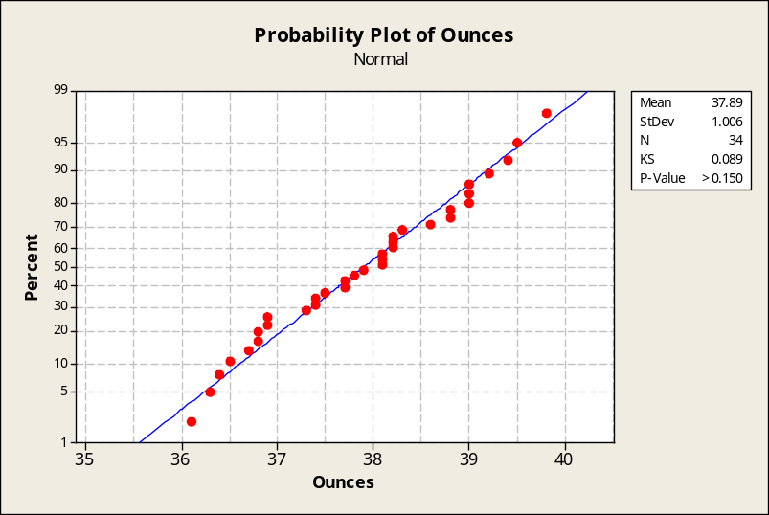

The chi-squared test of normality by Data Analysis Plus provides a comparable result.
In this test, p-value = 0.210 is not less than the 0.05 level for the test, and we conclude that the weights could have come from a normal population.

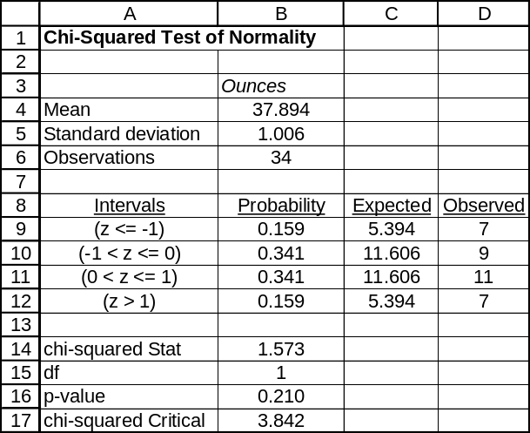

INTEGRATED CASES

THORNDIKE SPORTS EQUIPMENT

Ted is trying to compare the comfort of four seat designs for stationary bicycles across several sizes of riders, and the Friedman test is the appropriate method for him to use. The null and alternative hypotheses are:
H₀: the seating designs are equally comfortable
H₁: at least one seating design differs in comfort

For this test, d.f. = 4 - 1 = 3 and, for the 0.10 level, the critical value of F_{R} is 6.251. Ted uses the table below in his calculation of F_{R}:
 | seat design 1 | seat design 2 | seat design 3 | seat design 4
operator 1 | 1 | 4 | 2 | 3
operator 2 | 2 | 3.5 | 1 | 3.5
operator 3 | 2 | 4 | 3 | 1
operator 4 | 2 | 4 | 1 | 3
operator 5 | 2 | 3 | 1 | 4
operator 6 | 4 | 1 | 3 | 2
operator 7 | 2 | 4 | 1 | 3
 | sum = 15.0 | sum = 23.5 | sum = 12.0 | sum = 19.5

The calculated F_{R} = 6.56 exceeds the critical value, and we reject H₀. At the 0.10 level, there is evidence to suggest that at least one of the seat designs differs in comfort. Using only the chi-square table, we could find the p-value for this test to be between 0.05 and 0.10. The Minitab printout is shown below. Since p-value = 0.084 is < α = 0.10 level of significance for the test, we reject H₀.

Friedman Test: Score versus Seat, Rider

Friedman test for Score by Seat blocked by Rider

S = 6.56 DF = 3 P = 0.087
S = 6.65 DF = 3 P = 0.084 (adjusted for ties)

Est Sum of
Seat N Median Ranks
1 7 6.500 15.0
2 7 8.500 23.5
3 7 5.500 12.0
4 7 7.500 19.5

Grand median = 7.000

The corresponding Data Analysis Plus printout, which does not include adjustment for ties, is below.
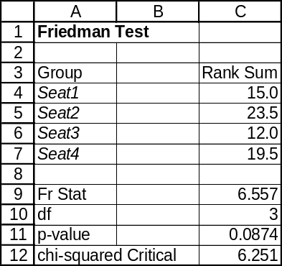

BUSINESS CASE

CIRCUIT SYSTEMS, INC. (B)

In Chapter 11, we visited Circuit Systems, Inc., a company that was concerned about the effectiveness of their new program for reducing the cost of absenteeism among hourly workers. In the process of analyzing that case, we created new variables (Cost_Before and Cost_After) for use in questions 2 and 3. If you did not save a database with the new variables included, you may wish to refer to the procedure described in the Chapter 11 solution to create them again.

1. Repeating question 1 from the Circuit Systems (A) case, but using the Wilcoxon signed rank test for paired samples instead of the dependent-samples t-test in comparing the two years in terms of days missed before and after the new program was implemented. For each employee we have created the variable Bef-AftDays = (days missed during year before program minus days missed during year following program implementation). The Minitab printout is shown below, and we will be using the 0.05 level of significance in reaching our conclusion.

Wilcoxon Signed Rank Test: Bef-AftDays

Test of median = 0.000000 versus median > 0.000000

N
for Wilcoxon Estimated
N Test Statistic P Median
Bef-AftDays 233 233 27071.0 0.000 4.375

The p-value for the test is extremely low, displayed here as 0.000, and this is < 0.05 level of significance for the test. On the basis of this test, the new program seems to be extremely effective in reducing employee absenteeism.

2. Repeating question 2 from the Circuit Systems (A) case, but using the Wilcoxon signed rank test for paired samples. For each employee we have created the variable BefCost-AftCost = (cost of absenteeism during year before program minus cost of absenteeism during year following program implementation). The Minitab printout is shown below, and we will be using the 0.05 level of significance in reaching our conclusion.

Wilcoxon Signed Rank Test: BefCost-AftCost

Test of median = 0.000000 versus median > 0.000000

N
for Wilcoxon Estimated
N Test Statistic P Median
BefCost-AftCost 233 229 15344.5 0.015 43.93

The p-value for the test is extremely low, and p-value = 0.015 is < 0.05 level of significance for the test. On the basis of this test, the new program seems to be extremely effective in reducing the cost of employee absenteeism.

3. Repeating question 3 from the Circuit Systems (A) case, we will use the Wilcoxon rank sum test for comparing independent samples, which is equivalent to the Minitab Mann-Whitney test. The Minitab printout is shown below, and we will be using the 0.05 level of significance in reaching our conclusion. (Note: Minitab expects the two samples to be in two separate columns. To do this, click Edit, click Command Line Editor, enter sort c5 c7 c21 c22 into the box, then click Submit Commands. You can then cut the lower portion of column 22 (i.e., the exercisers), paste the values into a separate column, and label the tops of the columns.

Mann-Whitney Test and CI: NonExers, Exers

N Median
NonExers 161 1061.8
Exers 72 1207.5

Point estimate for ETA1-ETA2 is -134.9
95.0 Percent CI for ETA1-ETA2 is (-194.4,-72.2)
W = 16815.0
Test of ETA1 = ETA2 vs ETA1 not = ETA2 is significant at 0.0000
The test is significant at 0.0000 (adjusted for ties)

In this case, we have done a two-tail test, and the p-value = 0.000 is < 0.05 level of significance for the test. The difference between the medians is extremely significant. However, the median cost associated with absenteeism for exercisers is $134.90 higher than that for persons participating in the exercise program! Again, keep in mind that part of the reason for the higher cost for exercise program participants is that the company is paying them $200 to be in the exercise program. As in our discussion in Circuit Systems, Inc. (A), we recommend that the subsidized exercise program should either be dropped or the amount of the subsidy reduced from the current $200.

